Setting Calendar Permissions in Outlook Web/New

Open outlook web access
Navigate to your calendar and click the three little dots
Choose sharing and permissions
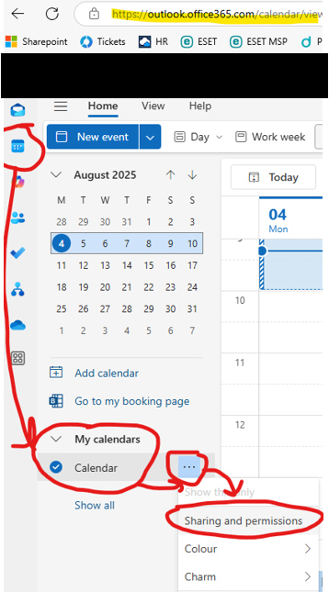

Search for the person you want to add or chose the person you want to edit and set the permission level
